GENERAL PURPOSE REGISTERS (GPRs)

The CPU's Workbench

Think of the CPU as a worker. **Registers** are the worker’s hands or small workbench.

They hold the tools and materials (data, addresses, pointers) the CPU needs right now.



I. Why they matter:

Registers give the CPU instant access to information.

Without them, the CPU would waste time going back and forth to RAM (the big library) or the Hard Drive (the warehouse).

II. How they work:

The CPU can’t use RAM directly. It must first copy data into a register.

Once in a register, the CPU can add numbers, compare values, or move data quickly.

III. Key Points:

* **Location:** Inside the CPU chip.
* **Speed:** Extremely fast — one cycle vs. hundreds for RAM.
* **Volatility:**

The 32-bit Registers

In this modern x86 architecture, we have eight special types of registers called general-purpose registers (GPRs). Each of these GPRs is a single 32-bit block. This is different from the earlier 16-bit registers that were used in older CPU models.



I. Breaking Down Each Register

Let's explore each register and its typical uses:

1. **AX**: Used for addressing data, pointing to specific locations.
2. **BX**: Similar to AX, used for addressing data, but often used for larger values (like 16-bit numbers).
3. **CX**: Often used for addressing data in addition to what's already stored in AX and BX.
4. **DX**: A bit different from the others, it's usually set by the program or hardware to point to a specific address.
5. **BP**: Used for storing addresses of previously loaded data (or code).
6. **SP**: This register holds the stack pointer, which is used to manage memory and return values.
7. **SI** (or **DI**): Usually linked to BP, SI stores the base address of a block of memory.
8. **EAX**, **EBX**, **ECX**, **EDX**: These registers are like AX, BX, CX, and DX, but with 16-bit widths instead of 32 bits.

So, in short, these eight registers provide direct access to your CPU's data storage locations, making them incredibly useful for efficient program execution.

In the x86 architecture, registers have grown over time. Intel maintained backward compatibility, meaning the names tell you the size.

* **8-bit (1970s):** AL, AH, BL, etc.
* **16-bit (1980s):** AX, BX, CX. (The "X" usually stands for pair or extended from 8-bit).
* **32-bit (1990s):** EAX, EBX, ECX. (The **"E"** stands for **Extended**).
* **64-bit (2000s):** RAX, RBX, RCX. (The **"R"** stands for **Register** or Re-extended).

*Note: In this chapter, we focus on the 32-bit "E" registers, as they are the standard baseline for malware analysis and reverse engineering.*

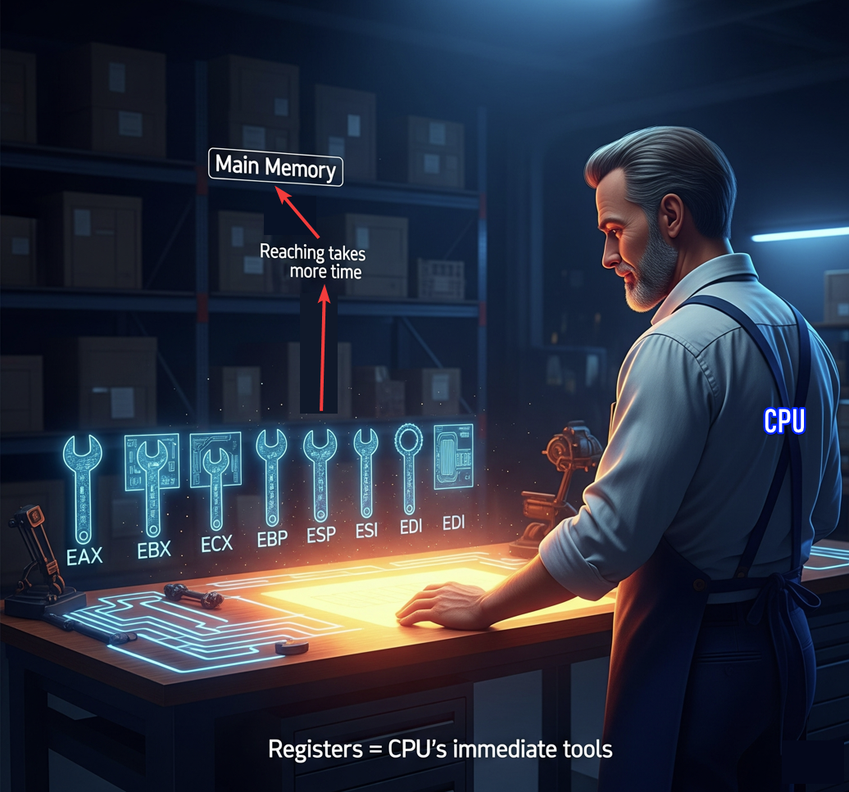

II. The Multi-Role Power Tools

The general-purpose registers in x86 are not just simple scratchpads. They're actually **multi-role power tools** that handle various tasks, such as data, pointers, counters, parameters, addresses, and even system calls.

Think of them like a set of versatile hammers, each one capable of performing different functions. For example:

* **AX** is for moving data - it can be used to load, store, or manipulate data in various locations.
* **BX** is similar to AX, but often used for *larger values* or *addressing higher memory* locations.
* **CX** is another type of register that's often used in addition to AX and BX.

III. Gaining Muscle in Protected Mode

In **protected mode (32-bit),** the general-purpose registers grew stronger and more powerful.

The first eight registers **AX to DI** became **EAX to EDI**, which are like a new set of tools with 16-bit widths instead of the original 8-bit width.

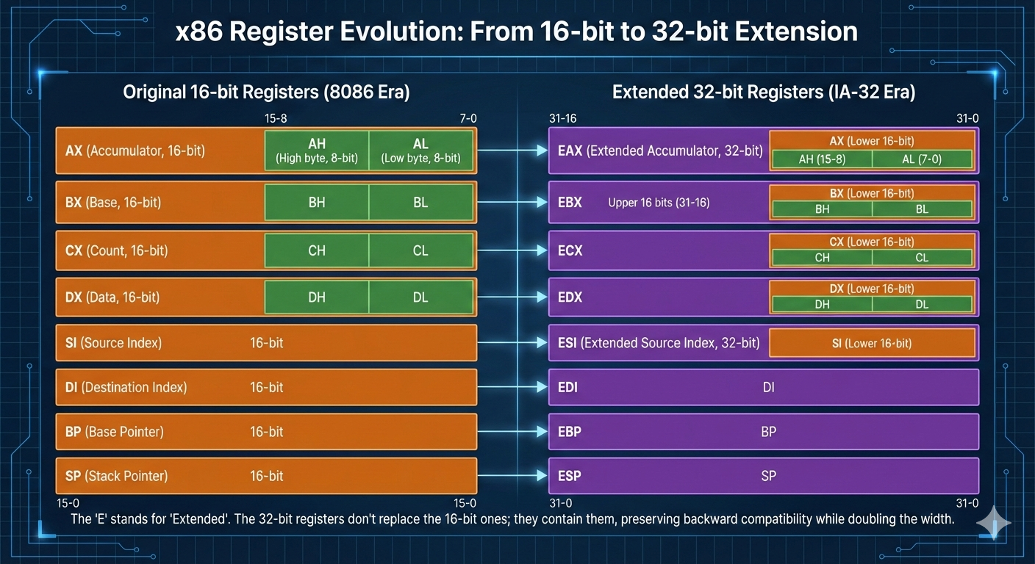

Later, in long mode (64-bit), even more registers were added:

* RAX to RDI: This is another "set of 8" with increased functionality.
* R8 to R15: These additional registers bring the total count to 16, providing a wider range of operations and tools for your CPU.

It's worth noting that these multi-role power tools are not just used in x86 processors; they're also found in other architectures, such as ARM and PowerPC.

3.2 The Core Four: Arithmetic & Logic

These four registers are unique because they can be sliced into smaller 8-bit pieces. This is a relic from the 1970s that is still used today to manipulate individual bytes (like characters in a string).

I. EAX: The Accumulator

* **Role:** The "Math Whiz."
* Most arithmetic (Addition, Multiplication) happens here. It is optimized for speed.
* **Programming Context:** In almost every operating system (Windows, Linux), **function return values** are stored in EAX.
  + *Reverse Engineering Tip:* If you see CALL CheckPassword followed by TEST EAX, EAX, the code is checking if the password was correct (usually 1 for success, 0 for fail).
* **Sub-parts:** AX (16-bit), AH (High 8-bit), AL (Low 8-bit).

II. EBX: The Base

* **Role:** The "Pointer."
* Traditionally used as a pointer to data in the Data Segment (DS). It holds the "Base" address of an array or object.
* **Modern Context:** It has no strict special purpose in modern compilers, so it is often used as a general storage bin for data that needs to stick around for a while.

III. ECX: The Counter

* **Role:** The "Loop Master."
* Used heavily in for loops and while loops. The CPU has a specific instruction called LOOP that automatically decreases ECX by 1.
* **Reverse Engineering Tip:** If you see REP MOVSB (Repeat Move String Byte), the CPU uses ECX to know how many bytes to move. It's the "Count" variable.

IV. EDX: The Data

* **Role:** The "Sidekick."
* EAX's partner. When you multiply or divide large numbers, the result might be too big for just EAX. The CPU spreads the result across **EDX:EAX** combined.
* **I/O Operations:** EDX is often used to hold the address of Input/Output ports.

**3.3 The Index Registers: High-Speed Movers**

These registers are designed for memory transfer operations (copying buffers, processing strings). They are the "logistics" team.

**3.3.1 ESI: Source Index**

* **Role:** "Where is the data coming *from*?"
* **Usage:** Holds the memory address of the source string or array during copy operations.

**3.3.2 EDI: Destination Index**

* **Role:** "Where is the data going *to*?"
* **Usage:** Holds the memory address where data will be pasted.
* **Analogy:** If you are moving houses, ESI is your old apartment, and EDI is your new house. The mover (CPU) walks from ESI to EDI.

**3.4 The Pointer Registers: The Stack Managers**

These two are critically important. You almost **never** use them for general math. Messing with these will crash your program instantly.

**3.4.1 ESP: Extended Stack Pointer**

* **Role:** "Top of the Stack."
* **Usage:** It always points to the very last item placed on the Stack memory.
* **Behavior:** When you PUSH a value, ESP moves down (memory addresses get smaller). When you POP, ESP moves up.
* **Warning:** Never manually overwrite ESP unless you are writing a compiler or an OS kernel.

**3.4.2 EBP: Extended Base Pointer (Frame Pointer)**

* **Role:** "The Anchor."
* **Usage:** It stays stationary during a function. It marks the start of the "Stack Frame."
* **Why?** Because ESP is constantly moving (pushing/popping), variables are hard to find relative to ESP. EBP sits still so you can say "My variable is at EBP - 4" or "My parameter is at EBP + 8."

**3.5 Register Breakdown Table (32-bit Architecture)**

Visualizing how the registers overlap is crucial. Remember: Changing AL **changes** EAX. They are the same physical wires.